**Problem statement 3: Food Security and Resource Optimization**

**Intelligent Food Ecosystem for Security and Sustainability**

**Overview:**

Our idea is a Tech-Integrated Ecosystem for Food Security, where every stakeholder in the food supply chain benefits from AI-driven insights to optimize food production, distribution, and consumption. The aim is to reduce food waste, enhance resource allocation, and improve access to food for all stakeholders, including farmers, producers, consumers, and NGOs. The system integrates advanced technologies like **image recognition, AI analysis, and matchmaking algorithms** to address inefficiencies in the food ecosystem. Additionally, a login page will be provided for different user roles to ensure privacy and secure access to the platform.

**1. Food Production**

**Objective:**

Support farmers by providing actionable insights to improve crop health and yield while minimizing losses.

**Key Features:**

1. **Crop Image Analysis**:

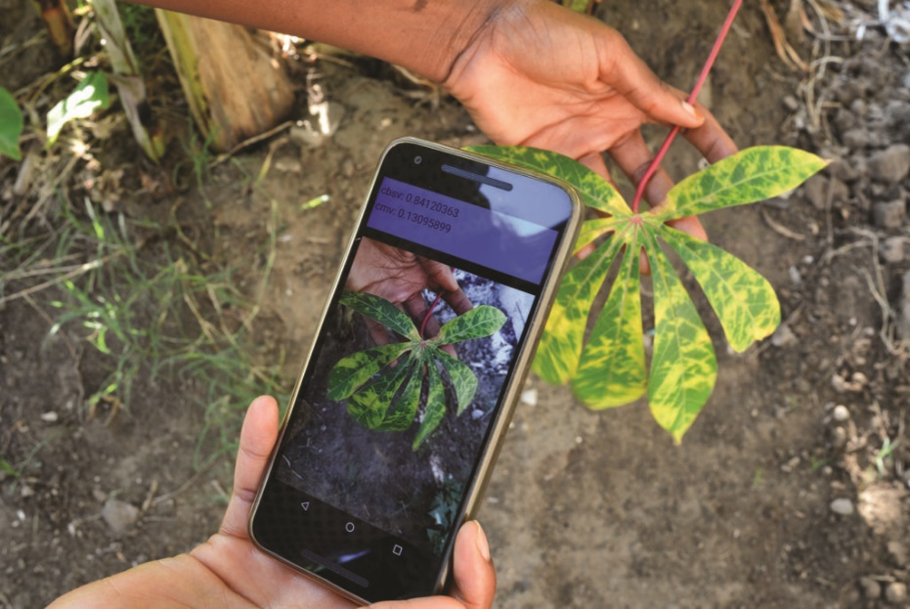

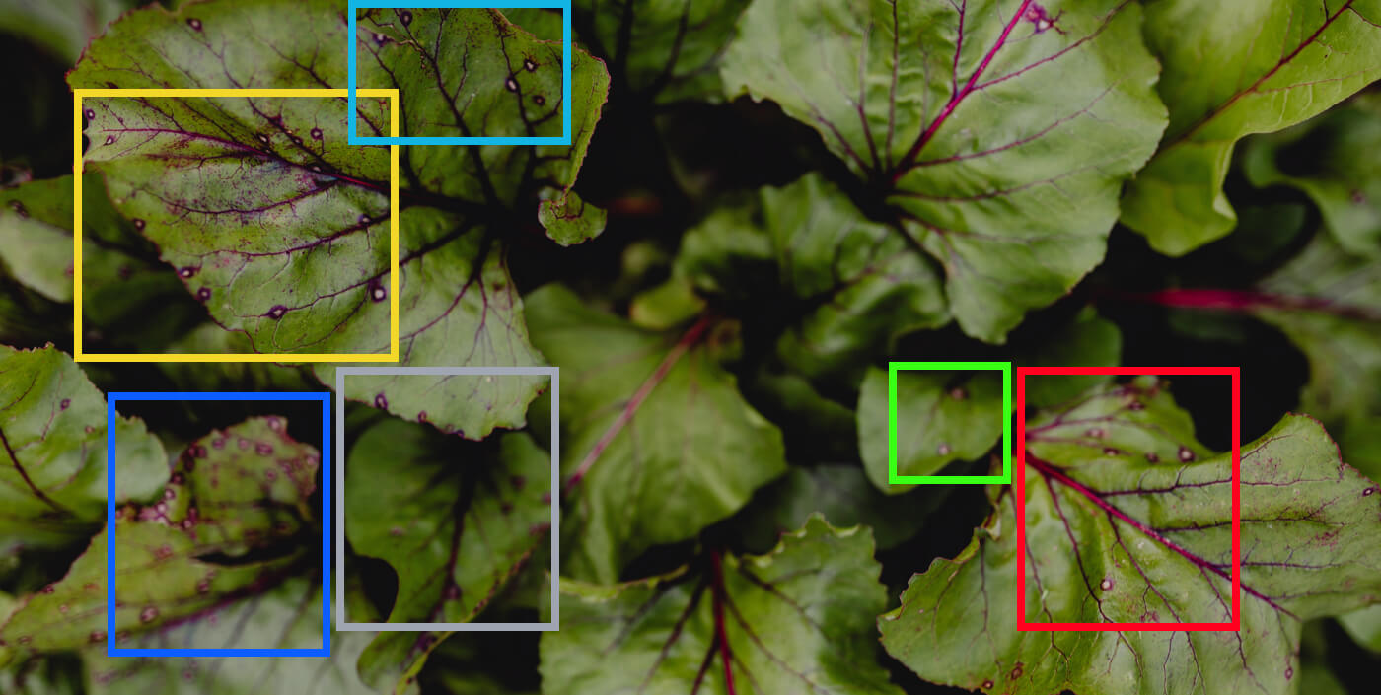

* + Farmers upload pictures of their crops through the app.
  + AI analyzes the images to identify:
    - Crop diseases.
    - Water requirements.
    - Nutrient deficiencies.
    - Pest infestations.
  + The system provides recommendations to address issues, including treatment methods and preventive measures.

1. **Localized Insights**:
   * Weather forecasts and irrigation schedules tailored to the farmer’s location.
   * Alerts for upcoming pest outbreaks or extreme weather conditions.
2. **Model Training**:
   * The platform is continuously updated with data from uploaded images to improve AI accuracy and broaden its scope of analysis.

**Impact**:

* Early detection of crop issues.
* Reduced dependency on harmful chemicals through targeted interventions.
* Higher crop yields and better resource utilization.

**2. Food Distribution**

**Objective:**

Streamline connections between producers and consumers to reduce surplus and ensure timely transactions.

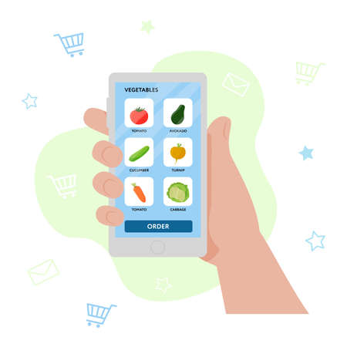

**Key Features:**

1. **Producer Platform**:
   * Producers (farmers, wholesalers) upload details of their available produce, including quantity, quality, and price.
   * The system suggests a list of local businesses, companies, or buyers interested in purchasing the produce.
   * Direct contact feature for negotiations and transactions.
2. **Consumer Platform**:
   * Consumers (retailers, businesses) post their requirements for specific types of produce, including quantity and delivery timelines.
   * The app matches these requirements with local producers and provides options to choose from.
3. **Matchmaking Algorithm**:
   * Uses AI to match producers with buyers based on proximity, price preferences, and supply-demand patterns.
   * Ensures minimal transportation time and costs.

**Impact**:

* Reduced post-harvest losses.
* Transparent pricing and improved access to local markets.
* Better profitability for farmers and wholesalers.

1. **Food Consumption**

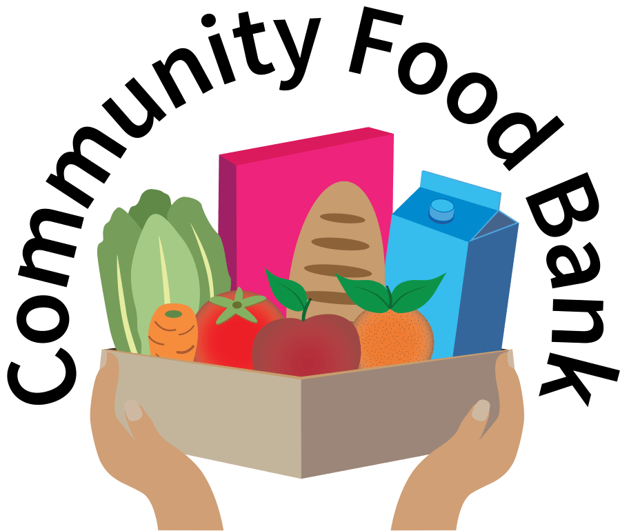 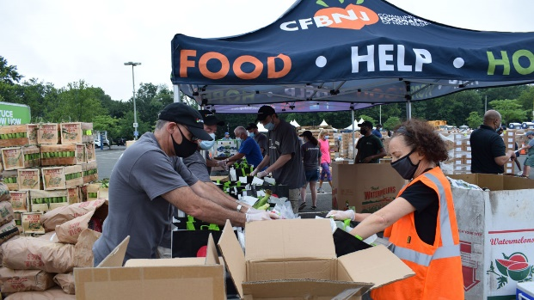

**Objective:**

Minimize food waste and ensure surplus food reaches those in need.

**Key Features:**

1. **Hotel and Business Integration**:
   * Hotels, restaurants, and food businesses upload details of leftover food or surplus inventory, including quantity and type.
   * The app categorizes the food based on usability and shelf life.
2. **NGO and Food Bank Connectivity**:
   * Lists local NGOs and food banks that can collect and redistribute the surplus food.
   * Real-time notifications to NGOs for new food availability.
3. **Community Impact Dashboard**:
   * Tracks the amount of food saved and distributed.
   * Encourages businesses by showing their contribution to reducing food insecurity.

**Impact**:

* Reduction in food waste.
* Improved access to food for underserved communities.
* Strengthened connections between food donors and NGOs.

**Unified Mobile Application**

* **Interface**: User-friendly app with dedicated sections for producers, consumers, and food donors.
* **Integration**: AI and machine learning for smart recommendations and automated insights.
* **Community Engagement**: Gamified incentives for participants to reduce food waste and contribute to the ecosystem.

**Expected Benefits**:

* Enhanced efficiency across the food value chain.
* Significant reduction in food waste.
* Empowered farmers and consumers with better tools for decision-making.
* Stronger community ties through food redistribution initiatives.

**Call to Action:**

Implementing this idea will not only optimize the food system but also pave the way for a more sustainable and equitable future. Let’s collaborate to make this vision a reality.